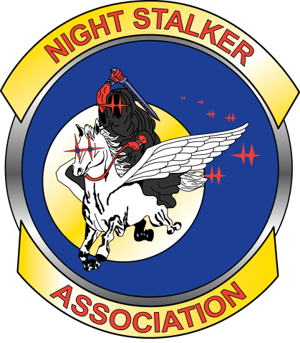

The 2018-20 NSA Officer Ballot

BallotBallot

Votes for the 2018-20 Vise-President and Quartermaster Officers for the Night Stalker Association must be submitted to the NSA no later than 17 December 2017.

The elected Officials will be announced Monday 18 December 2017.

YOU MUST BE AN ACTIVE MEMBER TO VOTE (one ballot per member).

Select or nominate your choice below. Print your name for member verification and sign the ballot. Thank you for taking the time to vote!

Vice-President (vote for one)

MR Ben Savage

Write in

Quartermaster (vote for one) No nominations received.

Write in ________________________________

Member Name

Signature

Instructions for submitting ballot (submit by one of the methods listed below):

1. Mail to or deliver to NSA 11304 Bell Station Road, Oak Grove KY 42262

2. Scan/photo ballot and email to: Mr Sam Roth sam.roth.ctr@socom.mil or Mrs Andrea Meyers andrea.meyers@nsa160.com place the words "Election Ballot" in the subject.

