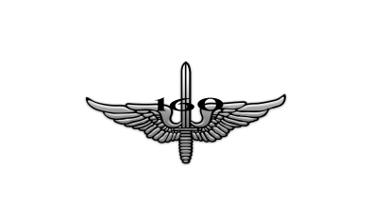2018 NSA Golf Scramble 

Wednesday, 30 May

07:30 a.m. and 1:00 p.m. Shotgun Start

The 2018 NSA Golf Scramble will be held on Wednesday, May 30st. Player slots will fill quickly; please fill out the entry form on the back of this card if you are playing.

• Cost is $75.00 per player, and fee MUST accompany your entry form (see reverse) in order to be registered.

• Registration: You can register and pay online via credit card at www.NSA160.com or at the NSA Store during normal business hours of 10:30 – 4:00.

• All players must be active members of the Night Stalker Association. If necessary, a membership application may be downloaded at www.NSA160.com by clicking on Membership under about tab.

• Registration begins at 9:00 a.m. on April 16th and closes at 3:00 p.m. on May 20th.

• VIP players may be paired with Soldiers to complete a four-man team.

• Lottery drawing will be held on May 24th to determine which teams will play in the morning and afternoon flights.

• Sign-in for all players begins one hour prior to shotgun start (06:30 a.m. and 12:00 p.m.).

• Scoring: Lowest score wins.

• Tees: (placed by tournament officials and Course staff).

• Preferred Lies: All players may place the ball within one club length of the selected ball (4 inches on the green). If a ball is to be played from the rough or bunker, ALL balls must be played from the rough or bunker.

• Personal Attire: Players will wear a collared shirt. No jeans or steel spikes allowed.

• A comprehensive rules brief will be conducted prior to play on tournament day.

**2018 NSA Golf Scramble Entry Form**

Name: ___________________________________________

Rank/Title: _______________________________________

Unit/Organization: _________________________________

Phone: ___________________________________________

E-mail: ___________________________________________

Shirt Size (M, L, XL)

NSA Member: (Circle) Yes No

*(If no, please attach NSA application and fee.)*

**Make checks payable to: NSA**

Submission and payment of fees assumes that you have read, understand, and will comply with the 2018 NSA Golf Scramble rules.

Email registration forms and questions to CPT Palange at [matthew.j.palange.mil@socom.mil](mailto:matthew.j.palange.mil@socom.mil) or call (270) 412-6298.

**Mail Return Entry Form and Fee To:**

Night Stalker Association

ATTN: 2018 NSA Golf Scramble

11304 Bell Station Road

Oak Grove, KY 42262