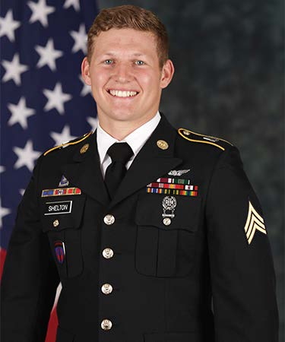

Sergeant Tyler M. Shelton
26 September 1998 – 27 August 2020

Sergeant Tyler M. Shelton was born on 26 September 1998 and was a native of San Bernardino, California. He was killed on 27 August 2020 while conducting aviation training on San Clemente Island, California, while assigned to Charlie Company, 1st Battalion, 160th Special Operations Aviation Regiment (Airborne).

SGT Shelton volunteered for service in the U.S. Army when he enlisted in 2016. He graduated from Basic Combat Training and Advanced Individual Training as a 15T UH-60 Black Hawk Repairer. Upon completion of his initial training, he was assigned to the 160th Special Operations Aviation Regiment (Airborne) at Fort Campbell, Kentucky, and completed Enlisted Combat Skills (Green Platoon) training. Upon completion of Green Platoon, he was assigned to Foxtrot Company, 1st Battalion, where he spent eight months as an MH-60M Repairer. In 2018, SGT Shelton was selected for Charlie Company, 1st Battalion, for service as an MH-60M DAP Crew Chief. While in Charlie Company, SGT Shelton served as a Fully Mission Qualified Crew Chief.

While assigned to the 160th, SGT Shelton deployed to Afghanistan in support of Operation FREEDOM’S SENTINEL. He flew over 500 hours in the MH-60M, including 200 hours under night-vision goggles.

SGT Shelton was a graduate of the Enlisted Combat Skills (Green Platoon), Combatives Level 1, MH-60 Maintainers Course, the Survival, Evasion, Resistance, and Escape (SERE) School, MH-60 Non-Rated Crew Member Course, and the Basic Leaders Course.

SGT Shelton’s awards and decorations include the Army Good Conduct Medal, National Defense Service Medal, Afghanistan Campaign Medal (w/1 Campaign Star), Global War on Terrorism Service Medal, Noncommissioned Officer Professional Development Ribbon, Army Service Ribbon, and the Basic Aviation Badge. He was posthumously awarded the Meritorious Service Medal and the Army Commendation Medal (w/C device).

SGT Shelton is survived by his wife, Alex; his mother Misty, and his father and step-mother, Michael and Tamara; his brothers, Hunter and Daniel; and his sister, Lillian.

